**CP Club 365Days Challenge**

**Date – 27/11/2022**

**Programming language – only C language**

**Problem Statement**

**Code must be in C language only**

<https://www.hackerrank.com/challenges/electronics-shop/problem?isFullScreen=true>

**Your Code**:

// 0x41Day of 0x365Days challenge

// VEDANT BHARAD

// 27-11-2022

#include <assert.h>

#include <limits.h>

#include <math.h>

#include <stdbool.h>

#include <stdio.h>

#include <stdlib.h>

#include <string.h>

char* readline();

char** split_string(char*);

int getMoneySpent(int keyboards_count, int* keyboards, int drives_count, int* drives, int b) {

    int moneySpent = 0;

    for(int loop1=0; loop1 < keyboards_count; loop1++) {

        for(int loop2=0; loop2 < drives_count; loop2++){

            if((keyboards[loop1]+drives[loop2]<=b) && (keyboards[loop1]+drives[loop2]>moneySpent)){

                moneySpent = keyboards[loop1]+drives[loop2];

            }

        }

    }

    if(moneySpent==0){

        return -1;

    }

    else{

        return moneySpent;

    }

}

int main()

{

    FILE* fptr = fopen(getenv("OUTPUT_PATH"), "w");

    char** bnm = split_string(readline());

    char* b_endptr;

    char* b_str = bnm[0];

    int b = strtol(b_str, &b_endptr, 10);

    if (b_endptr == b_str || *b_endptr != '\0') { exit(EXIT_FAILURE); }

    char* n_endptr;

    char* n_str = bnm[1];

    int n = strtol(n_str, &n_endptr, 10);

    if (n_endptr == n_str || *n_endptr != '\0') { exit(EXIT_FAILURE); }

    char* m_endptr;

    char* m_str = bnm[2];

    int m = strtol(m_str, &m_endptr, 10);

    if (m_endptr == m_str || *m_endptr != '\0') { exit(EXIT_FAILURE); }

    char** keyboards_temp = split_string(readline());

    int* keyboards = malloc(n * sizeof(int));

    for (int keyboards_itr = 0; keyboards_itr < n; keyboards_itr++) {

        char* keyboards_item_endptr;

        char* keyboards_item_str = *(keyboards_temp + keyboards_itr);

        int keyboards_item = strtol(keyboards_item_str, &keyboards_item_endptr, 10);

        if (keyboards_item_endptr == keyboards_item_str || *keyboards_item_endptr != '\0') { exit(EXIT_FAILURE); }

        *(keyboards + keyboards_itr) = keyboards_item;

    }

    int keyboards_count = n;

    char** drives_temp = split_string(readline());

    int* drives = malloc(m * sizeof(int));

    for (int drives_itr = 0; drives_itr < m; drives_itr++) {

        char* drives_item_endptr;

        char* drives_item_str = *(drives_temp + drives_itr);

        int drives_item = strtol(drives_item_str, &drives_item_endptr, 10);

        if (drives_item_endptr == drives_item_str || *drives_item_endptr != '\0') { exit(EXIT_FAILURE); }

        *(drives + drives_itr) = drives_item;}

    int drives_count = m;

    int moneySpent = getMoneySpent(keyboards_count, keyboards, drives_count, drives, b);

    // fprintf(fptr, "%d\n", moneySpent);

    printf("%d\n", moneySpent);

    fclose(fptr);

    return 0;

}

char* readline() {

    size_t alloc_length = 1024;

    size_t data_length = 0;

    char* data = malloc(alloc_length);

    while (true) {

        char* cursor = data + data_length;

        char* line = fgets(cursor, alloc_length - data_length, stdin);

        if (!line) { break; }

        data_length += strlen(cursor);

        if (data_length < alloc_length - 1 || data[data_length - 1] == '\n') { break; }

        size_t new_length = alloc_length << 1;

        data = realloc(data, new_length);

        if (!data) { break; }

        alloc_length = new_length;

    }

    if (data[data_length - 1] == '\n') {

        data[data_length - 1] = '\0';

    }

    data = realloc(data, data_length);

    return data;

}

char** split_string(char* str) {

    char** splits = NULL;

    char* token = strtok(str, " ");

    int spaces = 0;

    while (token) {

        splits = realloc(splits, sizeof(char*) * ++spaces);

        if (!splits) {

            return splits;}

        splits[spaces - 1] = token;

        token = strtok(NULL, " ");

    }

    return splits;

}

**Output (Screen Shot)**:

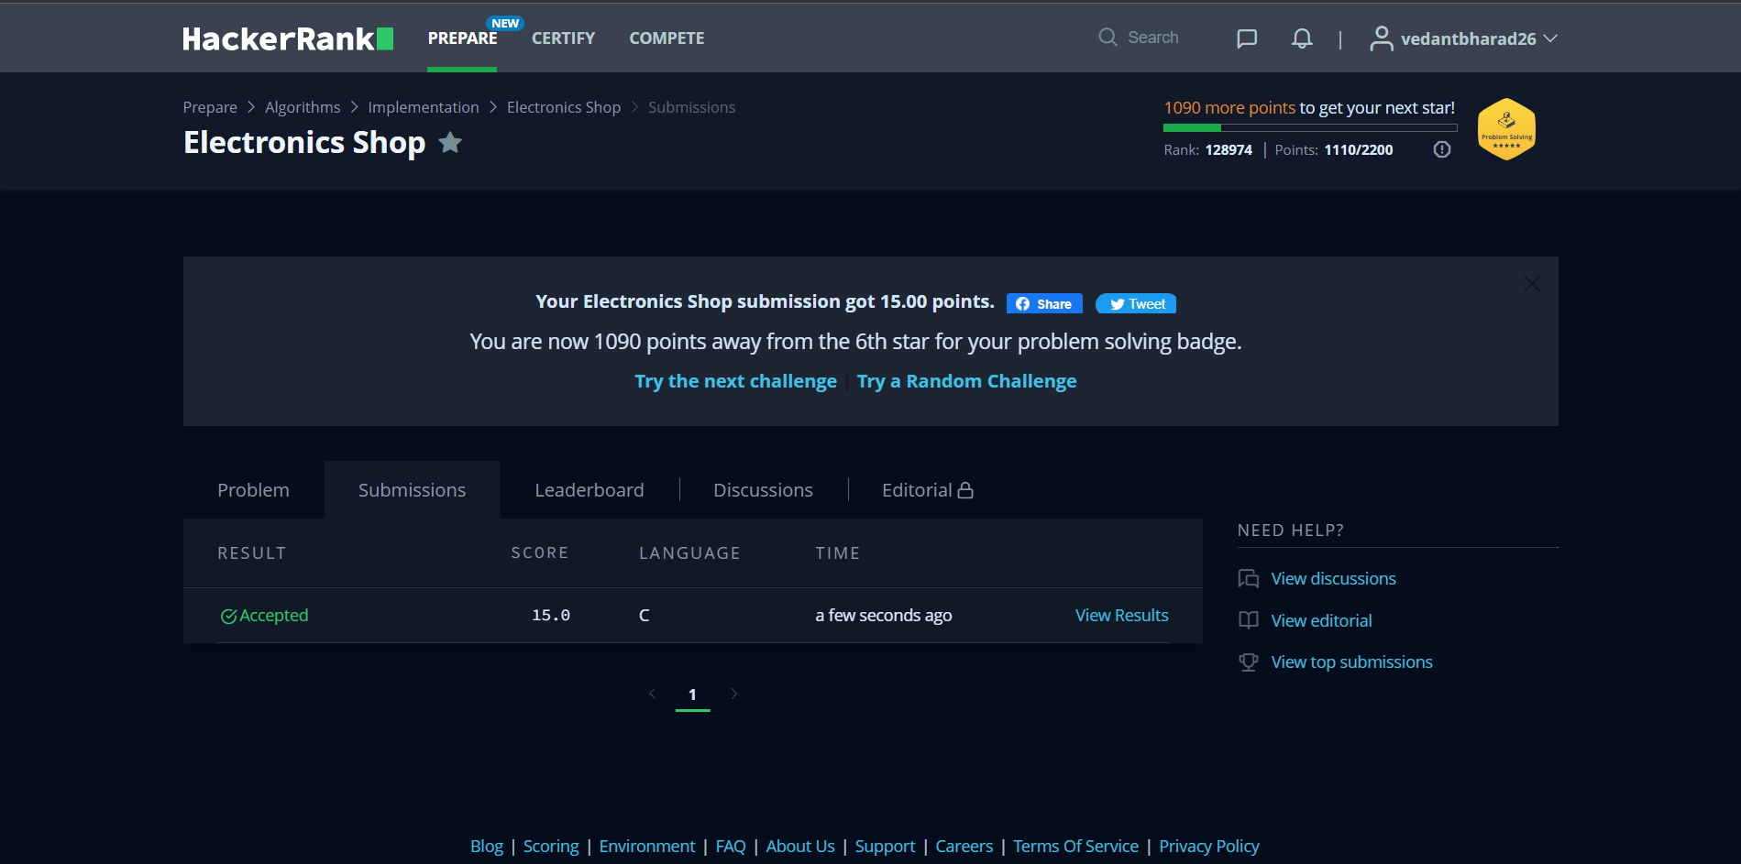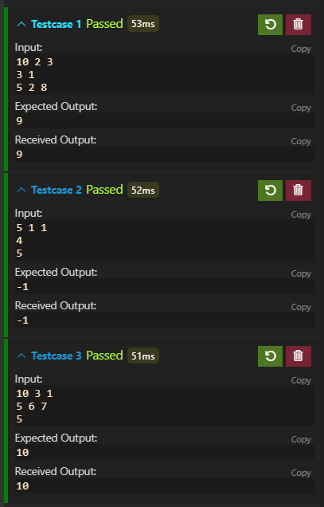

**Understanding about problem:**

* In this task there is 3 inputs in first line there are b=budget and length of two arrays and in second and third there will be array of price.
* In this task I need to return an int value which is count of two price and it should be less then or equal to b.

Note: If you can't understand the problem, feel free to contact us and we'll help you. Please don't copy and paste from anywhere.

ALL THE BEST

Team CP Club